Future Trends

An Introduction to Risk Models / Approaches
Risk models are a fundamental tool in the areas of security and risk management. Probabilistic and statistical methods, such as Monte Carlo simulations, Bayes Theory and TOPSIS, have been recommended and utilised by several sources including Hubbard (2020) and Downey (2012).
However, there are many other models used in economics and financial systems, and more recently several sources have proposed the use of these models in risk management as well. A brief selection of these models will be discussed in this section.
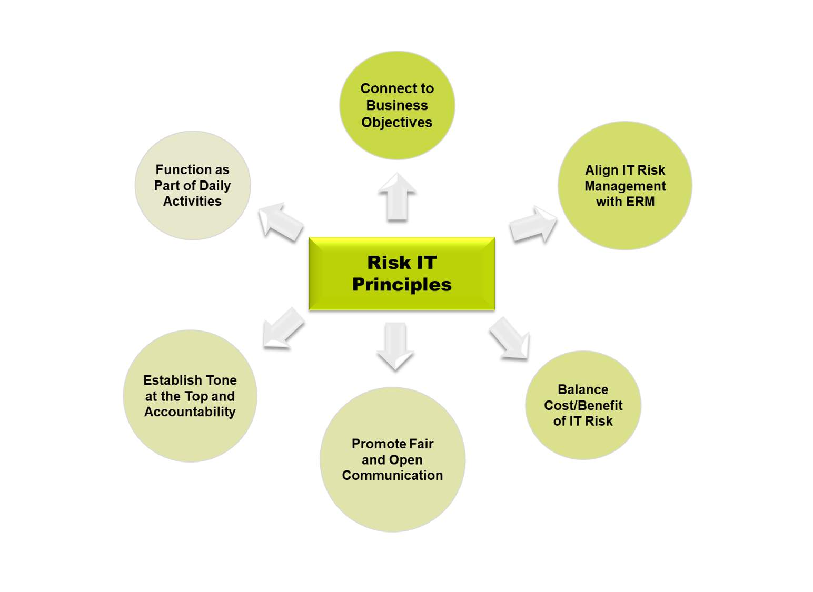

Real Options Theory
Absolutely, Payman. This section is introducing different models that help organisations make better risk-related decisions. You do not need to memorise the mathematics—just understand what each model is used for.

1. What are Risk Models?
Risk models are methods or frameworks used to:
- Identify risks
- Analyse risks
- Predict possible outcomes
- Support decision-making
Think of them as decision-support tools.
Cybersecurity example
A company wants to decide:
- Should we buy a new firewall?
- Should we move to the cloud?
- Should we invest in immutable backups?
Risk models help answer these questions.

2. Real Options Theory (ROT)
Simple idea
Real Options Theory says:
Don't commit to a big investment immediately. Keep your options open so you can expand, delay or stop the project depending on future events.
Like having an "option" without being forced to use it.
Example
A company wants to move to the cloud.
Instead of migrating everything:
- Move one department first.
- Evaluate results.
- Continue if successful.
- Stop if risks are too high.
This reduces risk.
Cybersecurity example
Instead of deploying a new Security Operations Centre (SOC) company-wide:
- Test it in one office.
- If successful, expand to the whole organisation.

3. Options Pricing Theory (Black-Scholes Model)
Simple idea
Originally used in finance.
It helps estimate:
How valuable an investment or opportunity is under uncertainty.
Businesses now use similar thinking to evaluate risky investments.
Example
Should a company invest £2 million in AI cybersecurity tools?
The model helps estimate:
- Future value
- Risk
- Time
- Uncertainty
Cybersecurity example
Should the company invest now in Zero Trust Architecture or wait another year?
The model helps compare those choices.

4. Operations Management (OM)
Simple idea
Operations Management is about:
Running a business efficiently.
It aims to:
- Save time
- Reduce costs
- Improve quality
- Increase productivity
Example
A factory wants to produce more products using fewer resources.
Operations Management improves the process.
Cybersecurity example
Automating patch management instead of updating computers manually.

5. Behavioural Operations
Simple idea
Behavioural Operations studies:
How human behaviour affects business decisions.
People don't always make perfectly logical decisions.
Their choices are influenced by:
- Cognitive biases
- Emotions
- Experience
- Culture
Example
A manager ignores a cybersecurity warning because:
"We've never been hacked before."
This is influenced by human bias rather than evidence.
Cybersecurity example
An employee clicks a phishing email because they trust an email that appears to come from their manager.
The problem is human behaviour, not technology.

6. Supply Chain Management (SCM)
Simple idea
Supply Chain Management ensures:
Products, software and services move securely and efficiently from suppliers to customers.
Today, software supply chains are also important.
Cybersecurity example
A company downloads a software library from an online repository.
If attackers insert malware into that library, every company using it could be affected.
Examples include:
- Typosquatting attacks (malicious packages with names similar to legitimate ones)
- Supply chain attacks
- SolarWinds attack

7. SolarWinds Attack
Attackers compromised SolarWinds software updates.
Customers trusted the updates and installed them.
The malware spread through the software supply chain.
This is called a supply chain attack.

Easy Summary Table
Model | Simple Meaning | Cybersecurity Example
Risk Models | Help organisations analyse and manage risk. | Choosing security investments.
Real Options Theory | Keep options open; invest gradually. | Pilot a cloud migration before full deployment.
Options Pricing Theory | Estimate the value of risky investments. | Decide whether to invest in Zero Trust now or later.
Operations Management | Improve business efficiency. | Automate patch management.
Behavioural Operations | Study how people make decisions. | Reduce phishing through user awareness training.
Supply Chain Management | Secure the flow of products and software. | Protect against software supply chain attacks like SolarWinds.

🎓 One-line exam notes
- Real Options Theory: Flexible decision-making by allowing organisations to delay, expand or abandon projects as circumstances change.
- Options Pricing Theory: Evaluates investment value under uncertainty.
- Operations Management: Improves organisational efficiency and resource utilisation.
- Behavioural Operations: Examines how human behaviour and biases influence operational decisions.
- Supply Chain Management: Manages and secures the flow of goods, services and software across organisations.

Enterprise Risk Management (ERM)
Historically, risk management was viewed very narrowly and handled separately in silos. Under this fragmented view of risk, businesses focused on specific potential events that could be insured against (e.g., property, safety, health).
Fraser & Simkins (2016)
Enterprise Risk Management Enterprise Risk Management (ERM) is a reaction against such siloing, arguing that (as the authors' state) "risk management should include all risks, not just specific ones that are easier to quantify, and that risks should be managed as a portfolio across the enterprise" (Fraser & Simkins, 2016). Their paper covers challenges encountered by many companies when trying to adopt ERM including overcoming misconceptions; internal business challenges including corporate culture, poor understanding of, and training in the principles of ERM, and not implementing ERM as a change management program. They also offer some recommendations around solutions to these challenges including how to design and implement an ERM policy; the use of ERM frameworks; and the use of language, terminology and more traditional risk management tools such as workshops, mailboxes and registers.

Lechner & Gatzert (2018)
–
They carried out a study that revealed that the adoption of an ERM approach has a positive effect on the bottom line of companies and of the value of the business to shareholders, which is an additional factor that contributes to its adoption.

Etges et al (2018)
–
They carried out research to develop a risk inventory tailored towards the health sector based on previous work from the ERM field. This is a vital development to improve the security of healthcare systems, and can also contribute to the wider field.

Niehaus (2017)
–
They investigated the relationship between ERM and the RMP. The author believes that the ERM approach:
- Places more emphasis on value creation as an objective of risk management;
- Emphasizes the identification of all major risks facing an organization, regardless of how they are categorized;
- Seeks to assess the aggregate risk facing the organization; and
- Considers a larger and more innovative set of methods/contracts to treat risk.
He defines a number of terms that are affected by the inclusion of an ERM facet such as risk (as defined within the ERM scope), risk objectives, and risk valuation as well as providing a number of examples that illustrate his arguments.

The author concludes "an ERM approach encourages a broader perspective when identifying risk, a deeper assessment of risk in part because one must assess how various risks within the organization interact and aggregate, and a consideration of a broader set of potential tools when deciding how to treat risk."
Absolutely, Payman. DevSecOps is one of the most important modern cybersecurity concepts, and it's actually quite straightforward once you understand the evolution.

DevSecOps
What is DevOps?
DevOps = Development + Operations
It is a way of working where:
- Software developers (Dev)
- IT operations (Ops)
work together instead of separately.
Before DevOps (Traditional)
Developers → Finish coding

↓

Operations → Deploy software

↓

Problems discovered later
The teams worked in silos, causing delays and conflicts.

What is DevSecOps?
DevSecOps = Development + Security + Operations
It adds security into every stage of software development.
Instead of checking security after the software is finished, security is built in from the beginning.
"Security is everyone's responsibility."

Continuous Security
Whenever developers write new code:
The system automatically performs:
- ✅ Security scanning
- ✅ Vulnerability scanning
- ✅ Code quality checks
- ✅ Compliance checks
- ✅ Automated testing
If a problem is found, it is fixed before the software goes live.

CI/CD Pipeline
CI = Continuous Integration
Developers regularly merge their code into a shared repository.
CD = Continuous Delivery/Deployment
The software is automatically tested and deployed after passing all checks.
Cybersecurity example
Developer writes new login code.
The CI/CD pipeline automatically:
- Runs unit tests
- Scans for vulnerabilities
- Checks coding standards
- Verifies security policies
Only if everything passes is the software deployed.

CAMS (John Willis)
Willis summarised DevOps with CAMS:
- C – Culture (collaboration)
- A – Automation (automate tasks)
- M – Measurement (monitor performance)
- S – Sharing (share knowledge)
These principles improve both software delivery and security.

Risk-based Security
Chegini (2022) argues that DevSecOps should use a risk-based approach.
This means:
Don't try to fix everything at once.
Instead:
- Identify the highest security risks.
- Prioritise them.
- Integrate security monitoring into the DevOps pipeline.

NoOps
Some researchers propose NoOps ("No Operations"), where cloud platforms automate almost all operational tasks.
However, this idea is debated because organisations still need people to:
- Manage security
- Respond to incidents
- Govern systems
- Make strategic decisions

🎓 Cybersecurity example
A company develops a mobile banking app.
Traditional approach
Security testing happens after development.
Problems are discovered late and are expensive to fix.
DevSecOps approach
Every code change automatically triggers:
- Static code analysis
- Vulnerability scanning
- Dependency checks
- Compliance testing
- Automated deployment
Security issues are identified and fixed early.

📝 One-line exam notes
DevOps
A collaborative approach where development and operations teams work together to deliver software faster and more efficiently.
DevSecOps
An extension of DevOps that integrates security into every stage of the software development lifecycle through automation, continuous testing and continuous monitoring.
CI/CD
Automated processes that continuously integrate, test and deploy software.
CAMS
The four principles of DevOps: Culture, Automation, Measurement and Sharing.

⭐ Easy memory trick
Traditional

Develop

↓

Release

↓

Security Testing ❌

DevSecOps

Develop

↓

Security Testing ✅

↓

Deploy

↓

Continuous Monitoring
🎯 Key takeaway for exams
The biggest difference is:
- DevOps focuses on speed and collaboration.
- DevSecOps focuses on speed, collaboration and built-in security.
Instead of treating security as the last step, DevSecOps makes security a continuous part of the entire software development lifecycle. This is why it is widely adopted in modern cybersecurity and cloud environments.

SAST
Sast (Static Application Security Testing) analyzes source code before it runs—like reading a blueprint to spot flaws early. It’s great for catching issues like SQL injection at the code level but can have false positives.

DAST
DAST (Dynamic Application Security Testing) tests a running app from the outside, simulating real attacks. It finds runtime vulnerabilities like broken authentication or XSS, but needs a live environment.
In short:
SAST = early, code-level checks (white-box)
DAST = real-world attack simulation (black-box)
Most teams use both for full coverage.
Copy
Good response
Bad response

ZAP
likely refers to Zed Attack Proxy (ZAP)—an open-source web application security scanner by OWASP. It's a popular DAST tool that actively tests running apps for vulnerabilities like SQL injection, XSS, and insecure configurations. Developers and security teams use it to find and fix security issues during testing or development. Let me know if you'd like help using it!

Machine Learning (ML)
Absolutely, Payman. This section is simply explaining how Machine Learning (ML) can improve cybersecurity and risk management, while also highlighting its own security risks.

Machine Learning (ML)
What is Machine Learning?
Machine Learning (ML) is a branch of Artificial Intelligence (AI).
It enables computers to:
- Learn from data
- Recognise patterns
- Make predictions or decisions
- Improve over time without being explicitly programmed
Cybersecurity example
Instead of manually checking millions of network events, an ML system can automatically detect suspicious behaviour that may indicate a cyberattack.

ML Safety (Varshney & Alemzadeh, 2017)
The authors argue that ML systems must be safe.
Their goal is:
Minimise both risk and uncertainty of harm.
They identify four principles.
1. Safe Design
Build ML systems securely from the start.
Example: Train an intrusion detection model using accurate, high-quality data.

2. Safety Reserves
Include a safety margin in case predictions are wrong.
Example: If the ML model is uncertain whether an email is phishing, send it for human review.

3. Safe Fail
If the ML system fails, it should fail safely.
Example: If an AI firewall stops working, the default action is to block suspicious traffic rather than allow everything through.

4. Procedural Safeguards
Support ML with policies, monitoring and human oversight.
Example: Security analysts regularly review the AI's decisions.

Machine Learning in Cybersecurity
ML is increasingly used to:
- Detect malware
- Detect phishing
- Detect network intrusions
- Identify insider threats
- Assess cyber risk
- Automate incident response

Reinforcement Learning (Ridley, 2018)
Reinforcement Learning (RL) is an ML technique where the system learns through trial and error.
It receives:
- Rewards for good decisions
- Penalties for bad decisions
Cybersecurity example
An autonomous cyber defence system learns how to:
- Detect attacks
- Isolate infected devices
- Apply security patches automatically
The more attacks it experiences, the better it becomes.

Recommender Systems (RS)
A recommender system suggests useful actions based on previous data.
You already use them every day:
- Netflix recommendations
- Amazon product suggestions
- YouTube recommendations
Cybersecurity example
A security platform might recommend:
- Enable MFA
- Patch a critical vulnerability
- Prioritise a high-risk server
- Update firewall rules

Adversarial Machine Learning
This studies:
How attackers can fool or manipulate ML systems.
Instead of attacking software, attackers attack the AI model itself.

Types of attacks

1. Quality attacks
Reduce the model's accuracy.
Example:
Attackers poison training data so malware is classified as safe.

2. Confidence attacks
Reduce trust in the AI.
Example:
If an AI repeatedly generates false alarms, analysts may stop trusting its alerts.

3. Evasion attacks
Attackers deliberately avoid detection.
Example:
A malware author slightly changes malware so the AI no longer recognises it.

Trustworthy AI (Trott & Wing)
The authors ask:
How can we prove that an AI system is trustworthy?
They suggest using formal methods (mathematical verification) to demonstrate that an AI behaves correctly and safely.
This is similar to formally proving that a security protocol works as intended.

🎓 Cybersecurity example
A bank uses ML to detect fraudulent transactions.
The AI:
- Learns normal customer behaviour.
- Flags unusual transactions.
- Suggests blocking suspicious payments.
However, attackers may try to manipulate the AI by making fraudulent transactions appear normal (an adversarial ML attack). The bank therefore combines AI with human analysts and formal testing to ensure the system remains reliable.

📝 One-line exam notes
Machine Learning (ML)
AI that learns from data to recognise patterns and make decisions.
Reinforcement Learning (RL)
An ML technique that learns through rewards and penalties.
Recommender System (RS)
An AI system that recommends actions or items based on previous data.
Adversarial ML
The study of attacks against machine learning models and methods to defend them.
Trustworthy AI
Ensuring AI systems are reliable, secure and behave as intended through verification and safeguards.

⭐ Easy memory trick
Concept | Remember it as
ML | Learns from data
RL | Learns by trial and error
RS | Suggests the best option
Adversarial ML | Attacking the AI itself
Trustworthy AI | Making AI reliable and secure
🎯 Key takeaway for exams
Machine Learning is becoming an important tool in cybersecurity because it can detect threats, automate responses and support decision-making. However, ML systems are also targets of attack, so organisations must design them safely, monitor them continuously and ensure they remain trustworthy. This balance between using AI for security and securing the AI itself is one of the major future trends in cybersecurity.
Lesson 6 of 10

NSA and the Hard Problems (Science of Security)
The National Security Agency (NSA) Science of Security (SoS) initiative started in 2012 and established a set of 'lablets' to investigate 'five hard problems' of cybersecurity that could be ameliorated by the application of rigorous scientific principles.
The goal is to develop foundations for the science of security — an explicit intellectual framework of process and methods for advancing scientific understanding and accelerating the transition of scientific results into practice.

Nicol & Scherlis, 2012
The goal is to develop foundations for the science of security — an explicit intellectual framework of process and methods for advancing scientific understanding and accelerating the transition of scientific results into practice.

Presentation
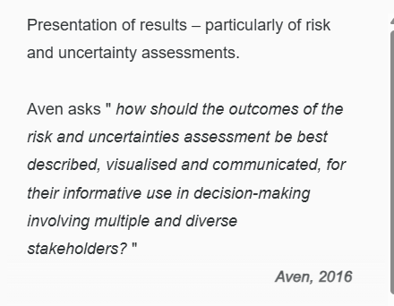
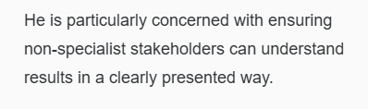

Measurement
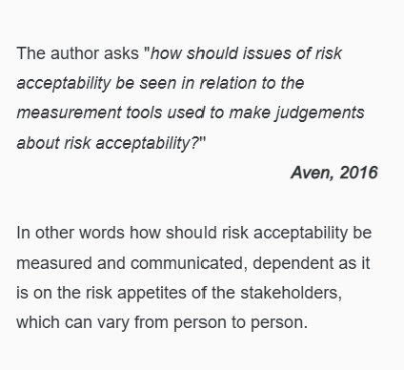

Selection
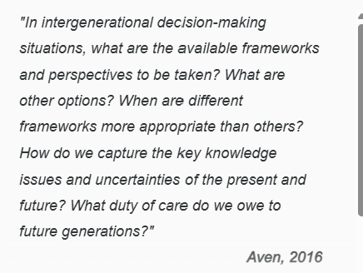
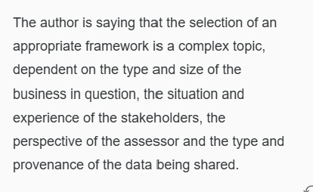

Representation
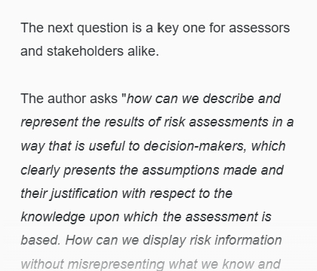
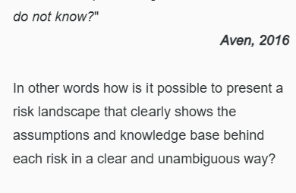

Confidence
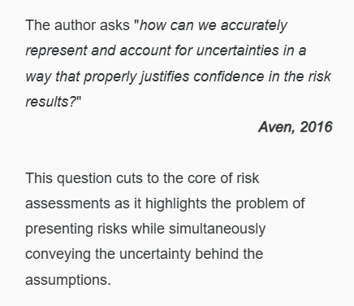

Quality
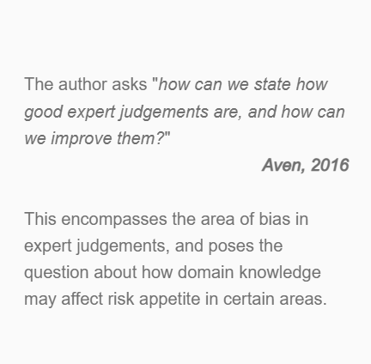

Approximation
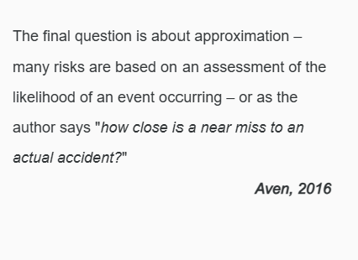
Of course! Here are very brief, exam-friendly definitions.
- Accelerating the transition of scientific results into practice
→ Applying research findings quickly in real-world cybersecurity and risk management.
- Presentation
→ How risk information is communicated clearly to decision-makers.
- Measurement
→ How risk is quantified or assessed using appropriate methods and metrics.
- Selection
→ Choosing the most suitable risk assessment framework or model for the situation.
- Representation
→ Presenting risk results together with assumptions, evidence and limitations.
- Confidence
→ The level of certainty or trust in the risk assessment results.
- Quality
→ Ensuring the assessment is accurate, reliable and based on sound expert judgement.
- Approximation
→ Using estimates or near-miss information when exact data is unavailable.
🎓 Cybersecurity example
Suppose you're assessing the risk of a ransomware attack:
- Presentation: Show the risk in a clear report.
- Measurement: Calculate the likelihood and impact.
- Selection: Choose NIST RMF or FAIR as the assessment method.
- Representation: Explain the assumptions and available evidence.
- Confidence: State whether confidence in the assessment is high, medium or low.
- Quality: Ensure experienced analysts performed the assessment.
- Approximation: Use previous phishing attempts or near misses if there hasn't yet been a successful ransomware attack.
These short definitions are ideal for quick revision before your seminar or exam.

